STATISTICS

ASSIGNMENT 2

Matteo Conta

FEMBA 9B



Consumer Research, Inc.

Consumer Research, Inc. is an independent agency that conducts research on consumer attitudes and behaviors for a variety of firms. In one study, a client asked for an investigation of consumer characteristics that can be used to predict the amount charged by credit card users. Data were collected on annual income, household size, and annual credit card charges for a sample of 50 customers.

Managerial Report
- Use methods of descriptive statistics to summarize the data. Comment on the findings.
I will first analyze the three variables separately, to see how the data is distributed.
Statistics
 | Income_($1000s) | Household_Size | Amount_Charged ($)
N | 50 | 50 | 50
Mean | 43.4800 | 3.4200 | 3964.0600
Median | 42.0000 | 3.0000 | 4090.0000
Mode | 30.00 | 2.00 | 3890.00
Std. Deviation | 14.5507 | 1.7390 | 933.4941
Skewness | .096 | .528 | -.130
Std. Error of Skewness | .337 | .337 | .337
Range | 46.00 | 6.00 | 3814.00
Minimum | 21.00 | 1.00 | 1864.00
Maximum | 67.00 | 7.00 | 5678.00
2*Std.dev/mean | 67% | 101% | 47%

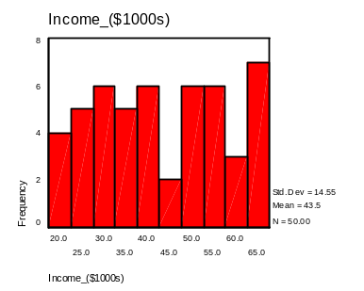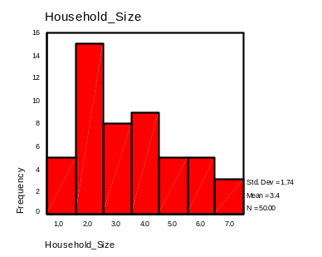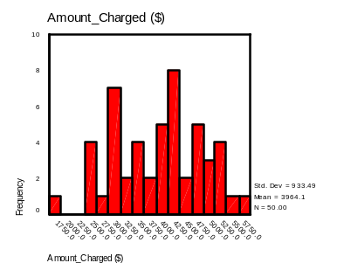

All three sets of data are significantly spread, since the standard deviation is a high percentage of the mean. The income data seems to be uniformly distributed, as the histogram suggests. The household size data is skewed, due to the fact that two persons compose the majority of households. The amount charged data seems to be more normally distributed.
With the help of the correlation matrix, I will analyze the sample correlation coefficients between each pair of variables:
 |  | Income ($1000s) | Household size | Amount Charged
Income ($1000s) | Pearson Correlation | 1.000 | .173 | .631
 | Sig. (2-tailed) | . | .231 | .000
Household size | Pearson Correlation | .173 | 1.000 | .753
 | Sig. (2-tailed) | .231 | . | .000
Amount  charged | Pearson Correlation | .631 | .753 | 1.000
 | Sig. (2-tailed) | .000 | .000 | .

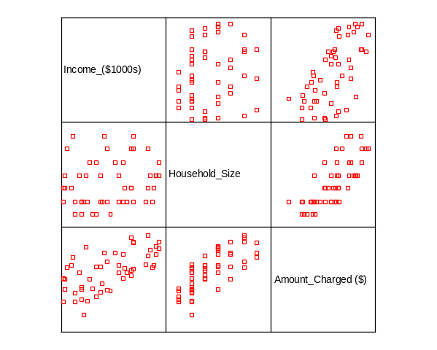

There is a correlation between amount charged and income and between amount charged and household size; on the other hand, it is possible to conclude with very high level of confidence (better that 99%) that there is no relationship between income and household size, as the scatter matrix plot suggests visually.

- Develop estimated regression equations, first using annual income as the independent variable, and then using the household size as the independent variable. Which variable is the better predictor of annual credit card charges? Discuss your findings.

- Simple linear regression: Amount Charged vs. Annual Income

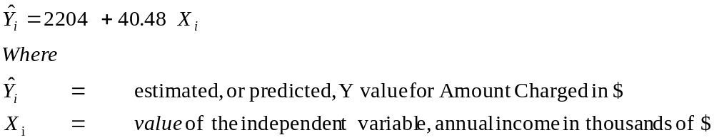

Significance of model:

 | Sum of Squares | df | Mean Square | F | Sig.
Regression | 16999744 | 1 | 16999744 | 31.751 | .000

Model is significant with more than 99% confidence level.
Residual analysis also shows no particular pattern and no problems of autocorrelation.

R | R Square | Adjusted R Square | Std. Error of the Estimate
.631 | .398 | .386 | 732

About 40% of the variation in Amount Charged is explained by annual income.
The Standard Error of the Estimate is a quite significant portion of the possible predicted values within the range: it is about 20% of the mode, and 40% of the minimum. This indicates that the error in the prediction using this regression equation may be high, and I would consider this model unacceptable if I were the client of Consumer Research, Inc.

- Simple linear regression: Amount Charged vs. Household Size

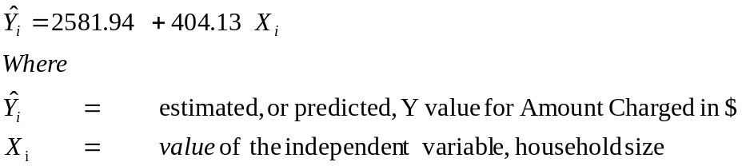

Significance of model:

 | Sum of Squares | df | Mean Square | F | Sig.
Regression | 2.4E+07 | 1 | 2.4E+07 | 63 | .000

Model is significant with more than 99% confidence level.
Residual analysis also shows no particular pattern and no problems of autocorrelation.

R | R Square | Adjusted R Square | Std. Error of the Estimate
0.753 | 0.567 | 0.558 | 621

Household Size explains about 60% of the variation in Amount Charged.

The Standard Error of the Estimate is a quite significant portion of the possible predicted values within the range: it is about 16% of the mode, and 33% of the minimum. This indicates that the error in the prediction using this regression equation may be high, and I would consider this model unacceptable if I were the client of Consumer Research, Inc.

Household Size is a better predictor of Amount Charged than Annual Income, since it does explain about 60% of the variation in Amount Charged, against only about 40% for Annual Income.

- Develop an estimated regression equation with annual income and household size as the independent variables. Discuss your findings.
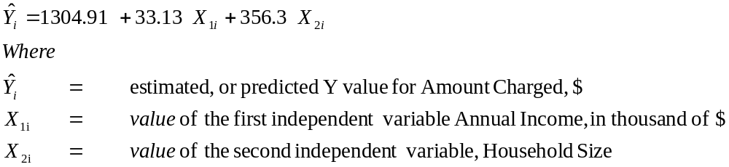

Significance of model:

 | Sum of Squares | df | Mean Square | F | Sig.
Regression | 3.5E+07 | 2 | 1.8E+07 | 111 | .000

Model is significant with more than 99% confidence level.

R | R Square | Adjusted R Square | Std. Error of the Estimate
0.91 | 0.826 | 0.8188 | 398

Household Size and Annual Income explain about 80% of the variation in Amount Charged.
The computer output also reports high level of significance for the single variables.
Residual analysis shows no violations of assumptions about the error term (trends, outliers, patterns) and the functional form of the model. There is no problem of multicollinearity.
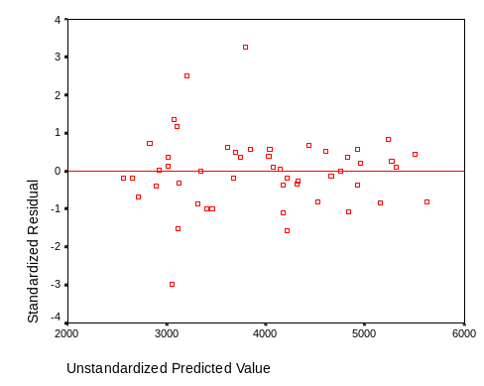

The Standard Error of the Estimate is reduced compared to the two previous simple linear regression models; this means that the model has actually improved. However, the Standard Error of the Estimate is still a quite significant portion of the possible predicted values within the range: it is about 10% of the mode, and 21% of the minimum. This indicates that the error in the prediction using this regression equation may be high, and I would consider this model unacceptable if I were the client of Consumer Research, Inc.

- What is the predicted annual credit card charge for a three-person household with an annual income of $40,000?

The predicted annual credit card charge for a three-person household with an annual income of $40,000 is about $3,700. The 95% confidence interval for the mean of the annual credit card charges for this values of income and household size is $3700$120, while for an individual prediction this interval widens to $3700$800, which I would consider unacceptable if I was the client of Consumer Research, Inc.

- Discuss the need for other independent variables that could be added to the model. What additional variables might be helpful?

Because the Standard Error of the Estimate is too big, as discussed in the previous questions, I see the need to improve the model, with the introduction of new variables. In order for the model to be really improved, new variables independent from the ones we already have need to be found. This will help avoiding the problem of multicollinearity and improving the Standard Error of the Estimate.
Following are some proposed variables with explanation on expected independence from the ones we already have in the model.
- Total household assets: I expect more money to be spent on credit card if the household is rich in assets, which doesn’t necessarily mean rich in income. Simply stated, I can afford to spend much of my income if I have already saved a lot for retirement, I own my house. I expect this variable to be low correlated with income (retired persons have high assets and low income, old workers have high income and high assets, young workers have low income and low assets) and with household size (if I have more kids, it does not necessarily mean that I have more assets).
- Number of credit card. The expected effect of this variable is that the higher the number of credit cards, the higher the total amount charged is likely to be. It will be low correlated with income, cause also low-income people have multiple cards, and low correlated with household size, even though some correlation may exist there. Last, but not least, the number of credit cards can be valuable information for the client and it is easily measurable.
- Purchase preference: cash or credit. People in certain households may have more a culture of spending by cash, meaning with money that they have, rather than by credit card, meaning with money that they may not have. This dummy variable can add some more precision into the model, and it is not correlated with the other proposed since it is the only one to involve cultural habits.
- Cash flow. This variable could be useful to model the typical situation of persons having a high income but limited money available to spend by credit card, since almost all the income is used to pay off bills and loans. It may be more difficult to gather, but it can add more precision to the model, and it should be rather independent from the previously mentioned.
- Average age of household. This variable is very easy to collect and will give some additional help to the model, if it turns out that it is independent from the others mentioned.
- Percentage of females in household. Based on the widespread belief that females like shopping more than men, and they also like the credit card for that, this variable could help refine further the model, and it is again very easy to collect.

